CSA1513-Cloud Computing
LAB EXPERIMENT -1
Create a simple cloud software application for Flight Reservation System using any Cloud Service Provider to demonstrate SaaS include the necessary fields such as one way, round
trip, From, to, Departure, Departure, Travelers &amp; Class, Fare Type, International and
Domestic Flights etc.
Aim: To develop a simple Cloud-Based Flight Reservation System using HTML, CSS, and JavaScript to demonstrate the Software as a Service (SaaS) concept.
Procedure:
- Create an HTML file for the Flight Reservation System.
- Design the user interface using HTML and CSS.
- Add flight reservation fields such as:
  - One Way / Round Trip
  - From and To
  - Departure and Return Date
  - Travelers
  - Class
  - Fare Type
  - Domestic / International
- Add sample flight details including flight name, flight number, departure time, arrival time, and fare.
- Use JavaScript to process the entered details.
- Display available flights with estimated travel time and total amount.
- Add a Book Flight button to display booking confirmation.
- Deploy the HTML application on a cloud platform to demonstrate SaaS.

PSEUDOCODE:
START

Display Flight Reservation System

Get:
Trip Type
Flight Type
From
To
Departure Date
Return Date
Travelers
Class
Fare Type

IF required fields are empty
Display error message
ELSE
Load available flight details

FOR each flight
Calculate total fare
Display:
Flight Name
Flight Number
Departure Time
Arrival Time
Estimated Duration
From and To
Class
Fare
Total Amount
Book Flight button
END FOR

IF user clicks Book Flight
Display booking confirmation
END IF
END IF

STOP

Output:
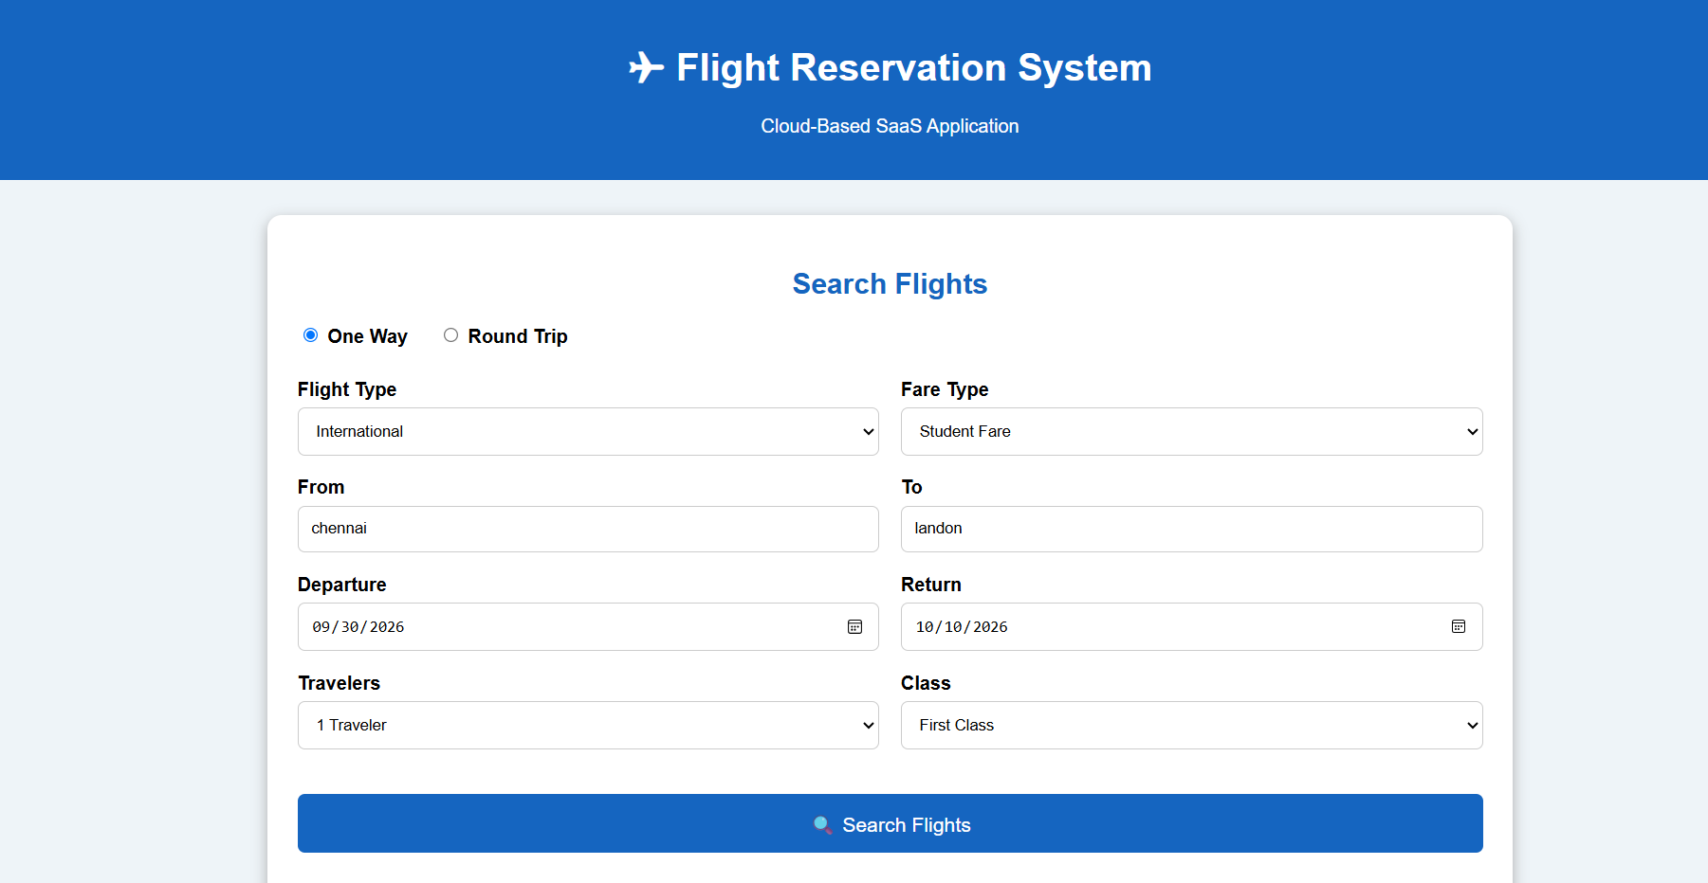

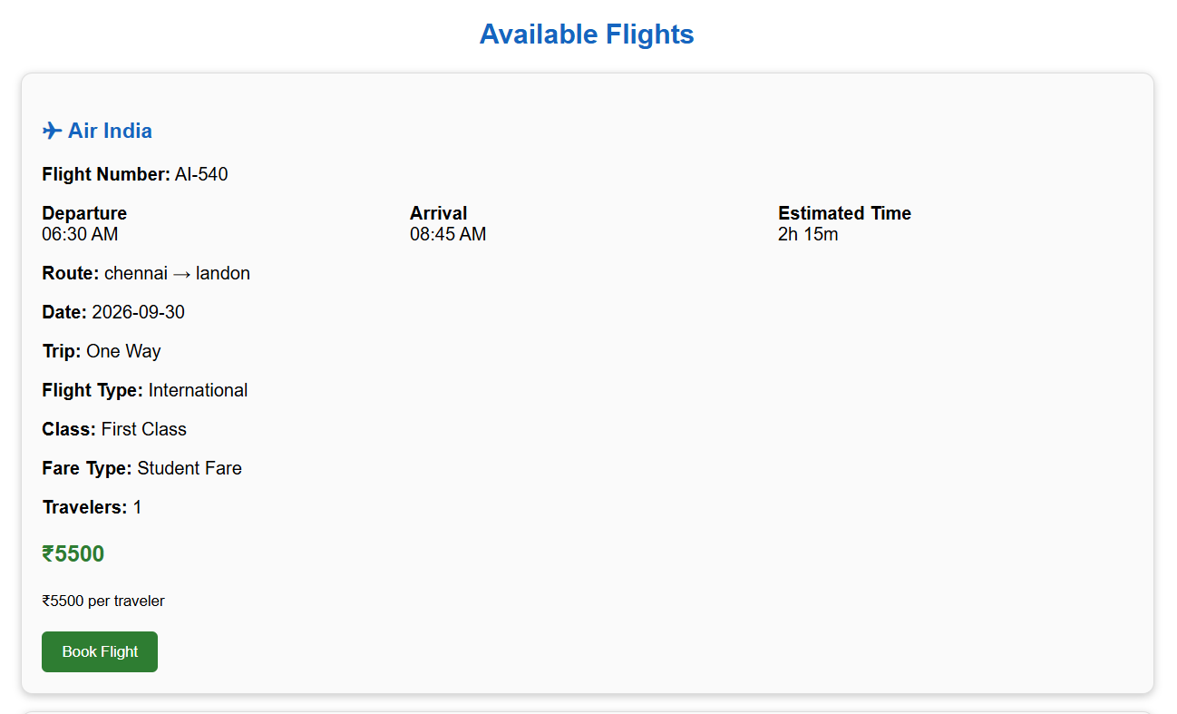
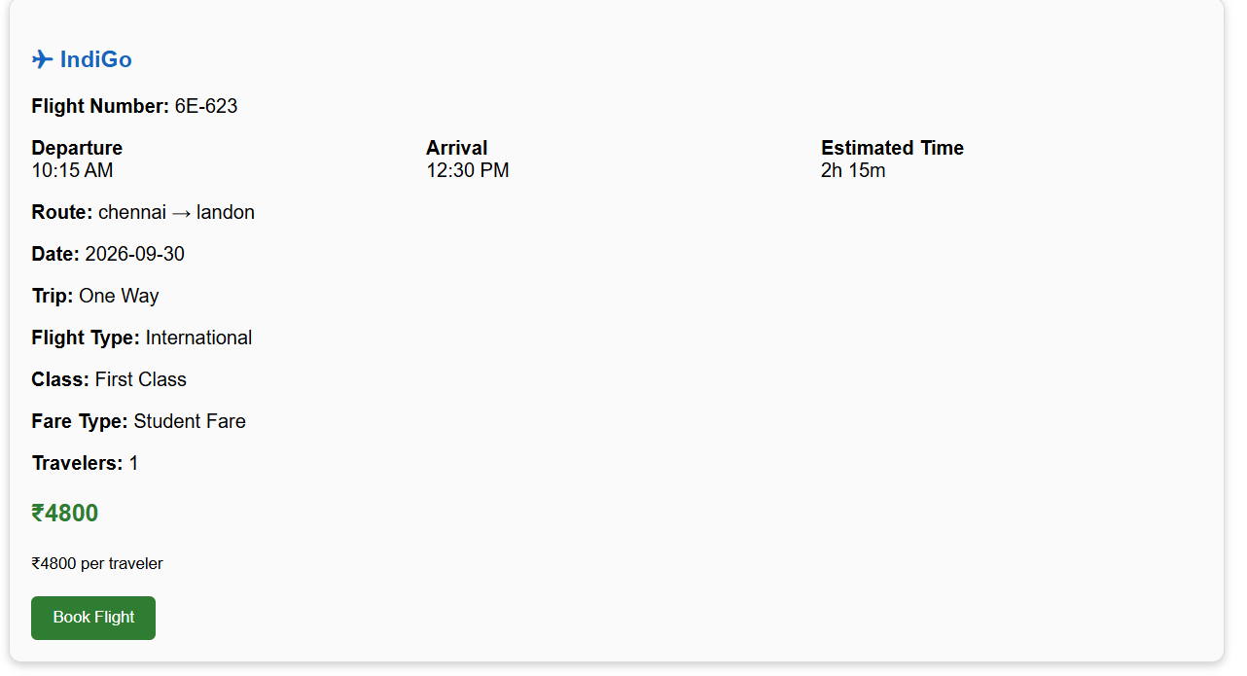
Result: The Cloud-Based Flight Reservation System was successfully developed. It allows users to enter journey details and displays available flights with flight name, flight number, departure time, arrival time, estimated travel duration, fare, and total amount, demonstrating the basic concept of SaaS in Cloud Computing.

LAB EXPERIMENT -2
Create a simple cloud software application for Property Buying &amp; Rental process (In Chennai city) using any Cloud Service Provider to demonstrate SaaS include the necessary fields such as Buy, Rent, commercial, Rental Agreement , Rental Agreement, Area, place, Range, property value etc.
Aim: To develop a simple Cloud-Based Property Buying and Rental System for Chennai City using HTML, CSS, and JavaScript to demonstrate the Software as a Service (SaaS) concept.
PROCEDURE
- Create an HTML file for the Property Buying and Rental System.
- Design the user interface using HTML and CSS.
- Add property search fields such as:
  - Buy / Rent
  - Residential / Commercial
  - Property Type
  - Area
  - Place
  - Price Range
  - Property Value
  - Rental Agreement
- Add sample Chennai property details.
- Use JavaScript to process the entered property requirements.
- Display matching properties with location, area, property value, rent, and agreement details.
- Add a View Property or Contact Owner option.
- Deploy the application on a cloud platform to demonstrate SaaS.
PSEUDOCODE
START
Display Property Buying & Rental System
Get:
Purpose (Buy / Rent)
Property Type
Category (Residential / Commercial)
Area
Place
Price Range
Property Value
Rental Agreement

IF required fields are empty
Display error message
ELSE
Load available property details

FOR each property
Check property requirements

IF property matches
Display:
Property Name
Property Type
Category
Area
Location
Property Value
Monthly Rent
Rental Agreement
Contact/View button
END IF
END FOR

IF no property matches
Display "No properties found"
END IF

IF user selects a property
Display property details
END IF

STOP
OUTPUT:
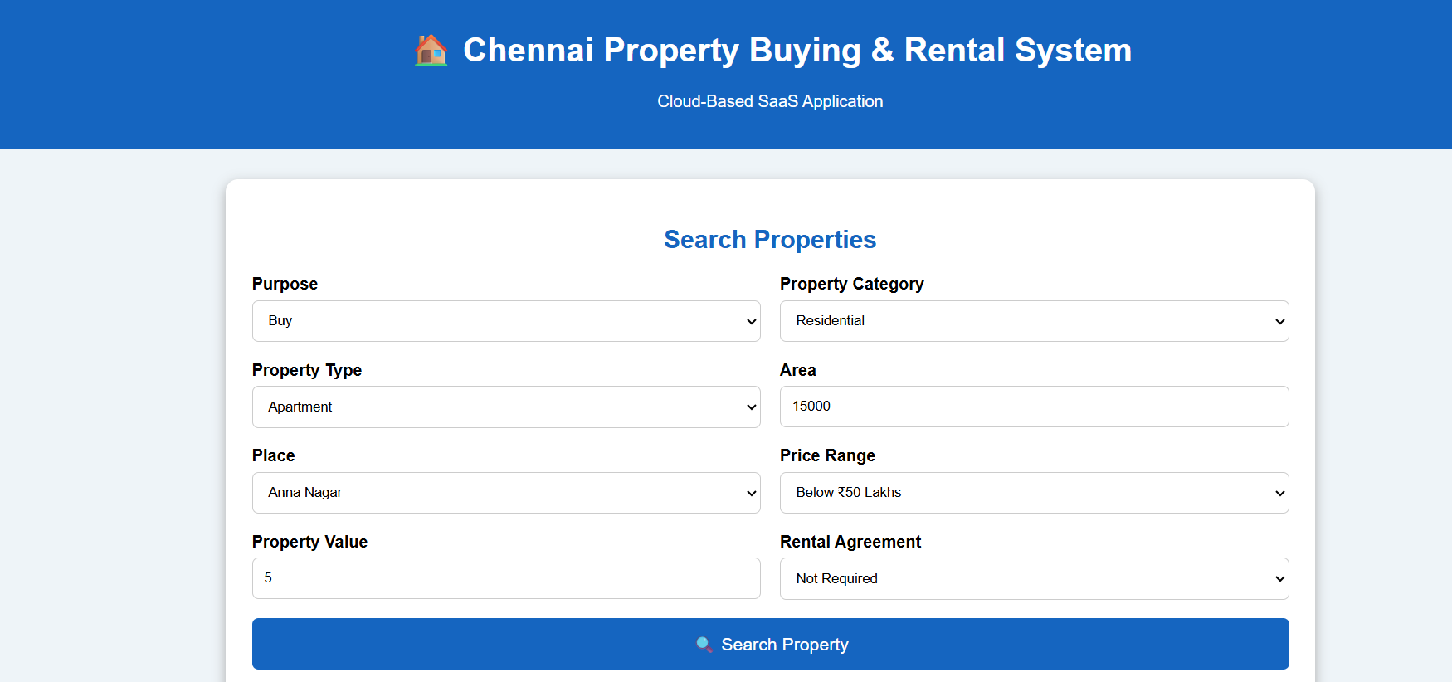
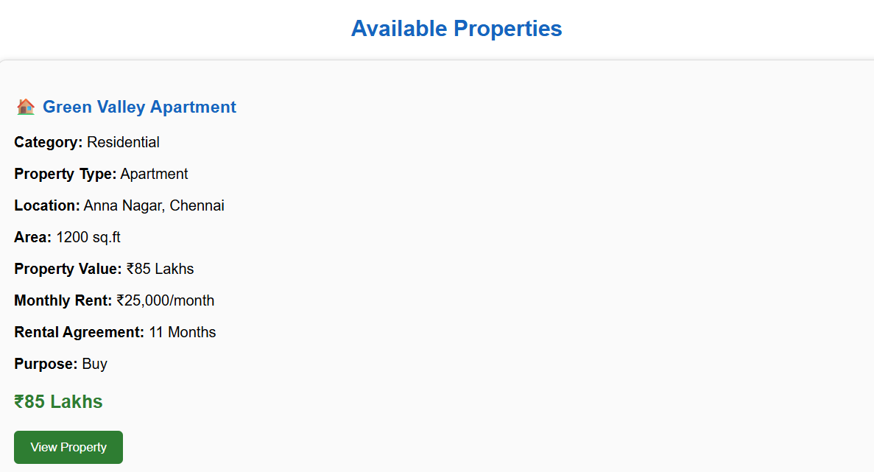
Result: The Cloud-Based Property Buying and Rental System for Chennai City was successfully developed. The application allows users to select Buy/Rent, Residential/Commercial, Area, Place, Price Range, Property Value, and Rental Agreement, and displays suitable properties with their location, area, price, rent, and other details, demonstrating the basic concept of SaaS in Cloud Computing.

LAB EXPERIMENT -3
Create a simple cloud software application for Car Booking Reservation System using any
Cloud Service Provider to demonstrate SaaS include the necessary fields such as search for
cabs, from, to, rental , out station, Package type, hours/Days etc.

AIM:
To develop a simple Cloud-Based Car Booking Reservation System using HTML, CSS, and JavaScript to demonstrate the Software as a Service (SaaS) concept.

PROCEDURE
- Create an HTML file for the Car Booking Reservation System.
- Design the user interface using HTML and CSS.
- Add booking fields such as:
  - Search for Cabs
  - From
  - To
  - Rental
  - Outstation
  - Package Type
  - Hours / Days
- Add sample cab details with cab type, driver name, fare, and estimated travel time.
- Use JavaScript to process the user's booking details.
- Display available cabs based on the selected requirements.
- Display fare and booking details.
- Add a Book Cab button for reservation.
- Deploy the application on a cloud platform to demonstrate SaaS.
PSEUDOCODE
START
Display Car Booking Reservation System
Get:
Booking Type
From
To
Package Type
Hours / Days
Rental / Outstation
IF required fields are empty
Display error message
ELSE
Load available cab details
FOR each cab
Calculate fare
Display:
Cab Name
Cab Type
From
To
Package Type
Duration
Estimated Time
Fare
Book Cab button
END FOR
IF user clicks Book Cab
Display booking confirmation
END IF
STOP
Output:
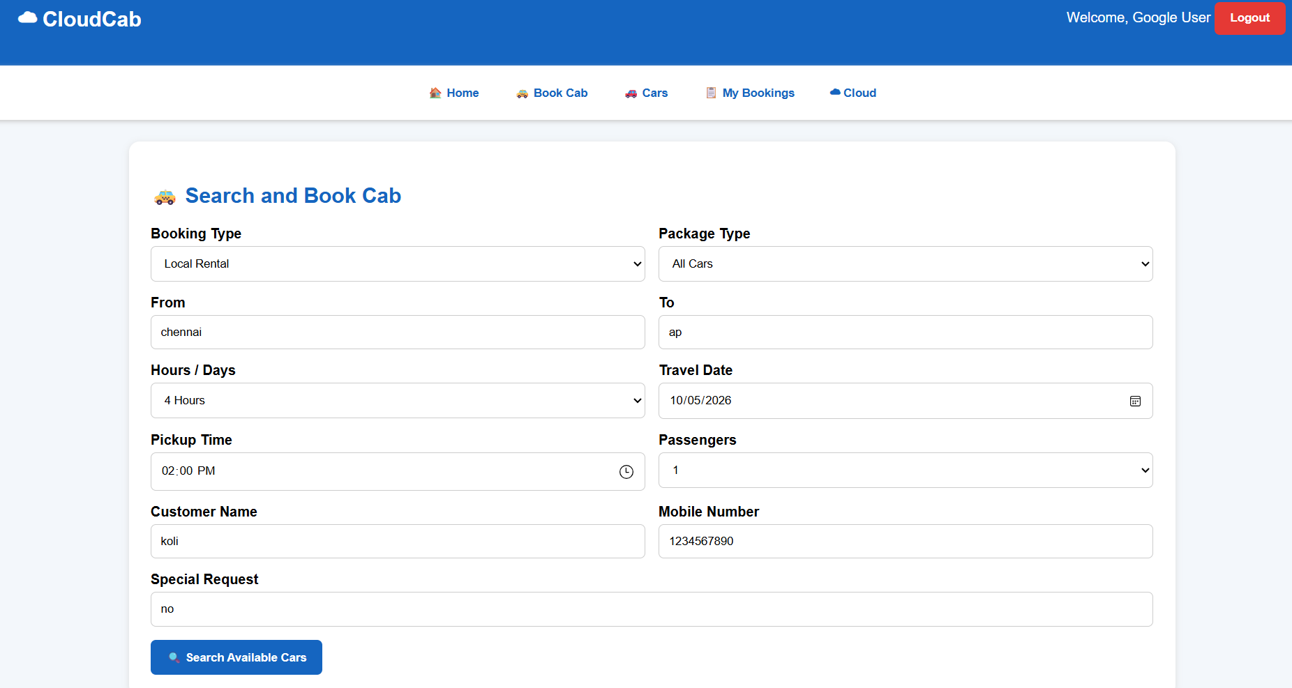

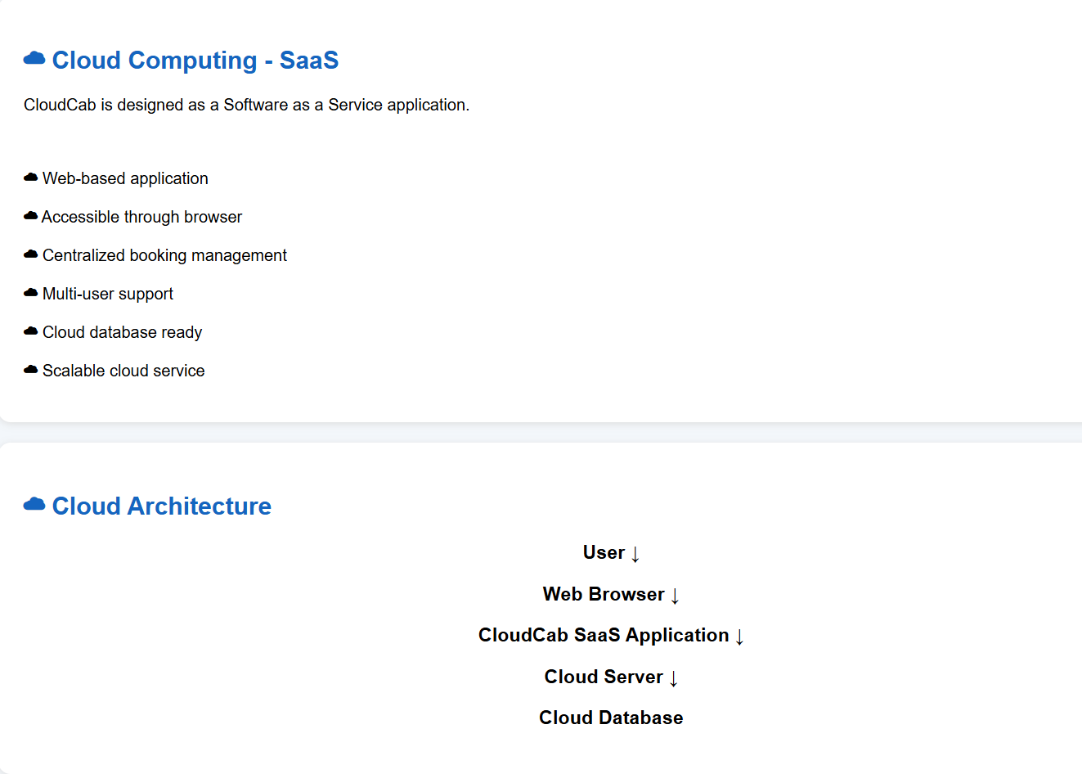
Result: The Cloud-based Car Booking Reservation System was successfully developed using HTML, CSS, and JavaScript. Users can search and book different cars, view fare details, and manage bookings. The application demonstrates the basic SaaS concept through web-based cloud access.

LAB EXPERIMENT -4
Create a simple cloud software application for Library book reservation system for SIMATS library using any Cloud Service Provider to demonstrate SaaS include the necessary fields such as Title of the book, author, publications, Year, edition, no of copies, Rack no, status (taken/returned) etc.
AIM
To develop a simple Cloud-based Library Book Reservation System for SIMATS Library using a Cloud Service Provider to demonstrate the Software as a Service (SaaS) model.

PROCEDURE
- Create a web-based library reservation application.
- Add book details such as Title, Author, Publication, Year, Edition, No. of Copies, Rack No., and Status.
- Provide options to search and check book availability.
- Allow students to reserve available books.
- Update the book status as Taken or Returned.
- Display reservation history and book details.
- Deploy the application using a cloud platform such as AWS, Microsoft Azure, or Google Cloud.
- Access the application through a web browser as a SaaS application.
PSEUDO CODE:
START
Login to Library System
Display Dashboard
Enter book details:
Title
Author
Publication
Year
Edition
Number of Copies
Rack Number
Status
Display available books
IF book is available THEN
Select book
Reserve book
Decrease number of copies
Set status = Taken
ELSE
Display "Book Not Available"
END IF
IF book is returned THEN
Increase number of copies
Set status = Returned
END IF
Display reservation history
Store and access data through Cloud
STOP
Output:
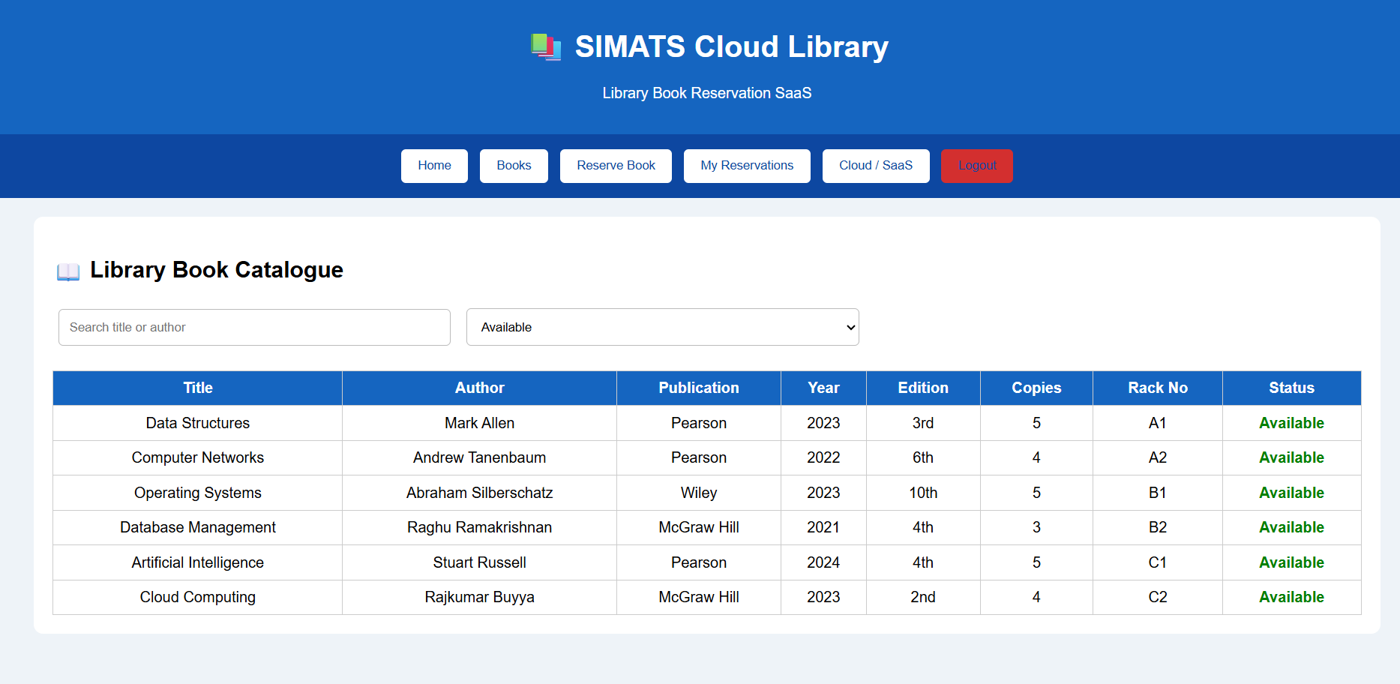
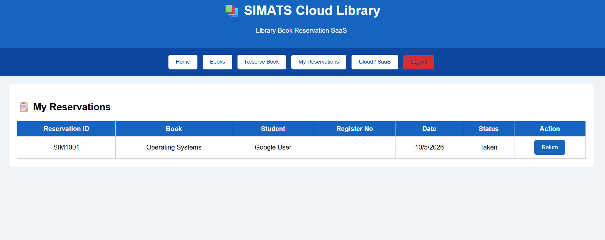
Result: The Cloud-based SIMATS Library Book Reservation System was successfully developed. It allows users to search, reserve, and return books while managing book details and availability. The application demonstrates the SaaS model through cloud-based access.

LAB EXPERIMENT -5
Create a simple cloud software application for Mark Sheet Processing System using any
Cloud Service Provider to demonstrate SaaS include the necessary fields such as name of the
student, Reg no of the student , Subjects , Marks, Average, percentage, rank, overall
performance etc.

AIM
To develop a simple Cloud-based Mark Sheet Processing System using a Cloud Service Provider to demonstrate the Software as a Service (SaaS) model for processing and analyzing student marks.
PROCEDURE
- Create a web-based mark sheet processing application.
- Enter Student Name, Register Number, Subjects, and Marks.
- Calculate the Total, Average, and Percentage.
- Determine the student's Rank and Overall Performance.
- Display the processed mark sheet.
- Store student details and results using a cloud database.
- Deploy the application using AWS, Microsoft Azure, or Google Cloud.
- Access the application through a web browser as a SaaS application.
PSEUDO CODE
START
Login to Mark Sheet System
Enter:
Student Name
Register Number
Subject Marks
Calculate:
Total = Sum of Marks
Average = Total / Number of Subjects
Percentage = (Total / Maximum Marks) × 100
Determine Rank
IF Percentage >= 90
Performance = "Excellent"
ELSE IF Percentage >= 75
Performance = "Very Good"
ELSE IF Percentage >= 50
Performance = "Good"
ELSE
Performance = "Needs Improvement"
END IF
Display Mark Sheet
Store Result in Cloud
STOP
Output:
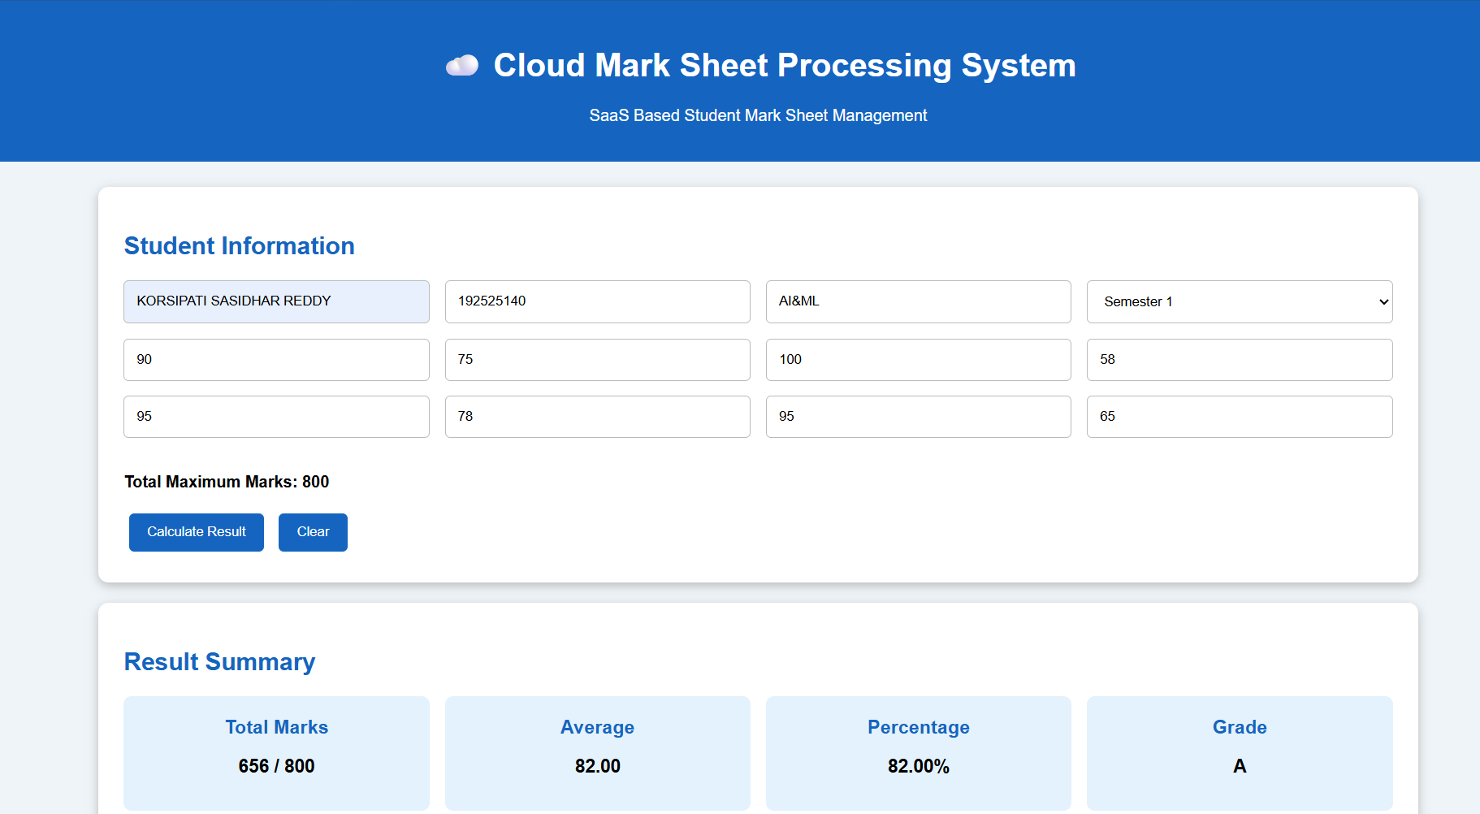
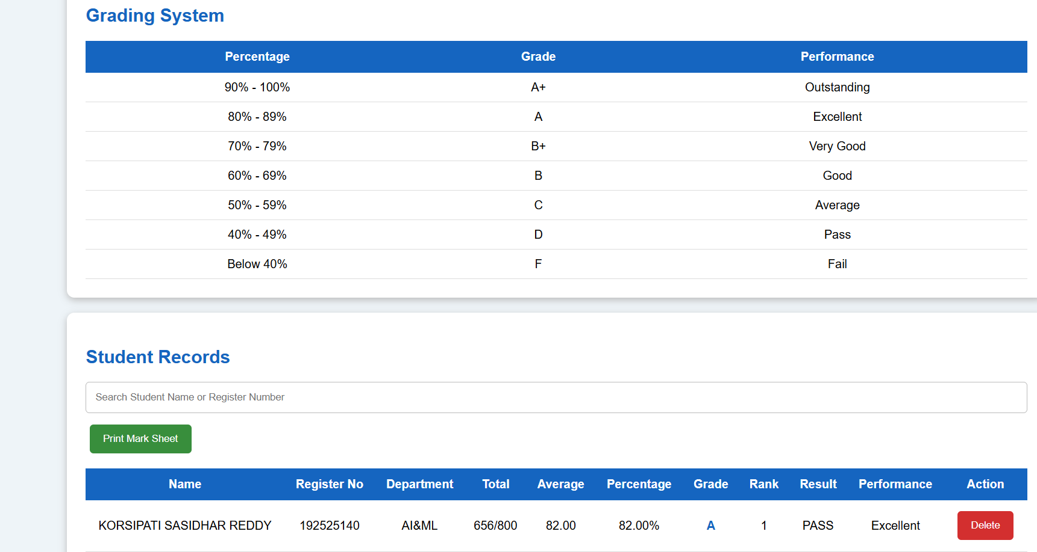
Result: The Cloud-based Mark Sheet Processing System was successfully developed. It calculates students' total marks, average, percentage, rank, and overall performance. The system demonstrates SaaS by providing cloud-based access to student results.

LAB EXPERIMENT -6
Create a simple cloud software application for Payroll Processing System using any Cloud
Service Provider to demonstrate SaaS include the necessary fields such as Name of the
employee, experience in present org , over all experience, basic pay, HRA, DA, TA, net pay,
gross pay etc.
Aim: To develop a simple cloud-based Payroll Processing System using HTML, CSS, and JavaScript to demonstrate the Software as a Service (SaaS) model, including employee details, salary calculation, allowances, deductions, gross pay, and net pay.
PROCEDURE:
- Create an HTML file named payroll.html.
- Design the payroll interface using HTML and CSS.
- Add employee details such as:
  - Employee Name
  - Employee ID
  - Department
  - Designation
  - Present Organization Experience
  - Overall Experience
- Add salary fields such as:
  - Basic Pay
  - HRA
  - DA
  - TA
  - Other Allowance
- Add deduction fields such as:
  - PF
  - Professional Tax
  - Other Deduction
- Use JavaScript to calculate:
  - Total Allowance
  - Gross Pay
  - Total Deduction
  - Net Pay
  - Salary Grade
- Display employee payroll records in a table.
- Provide additional features such as search, edit, delete, print, and CSV export.
- Run the HTML file in a web browser.
- The application can be deployed on a Cloud Service Provider to demonstrate SaaS.
PSEUDO CODE:
START
Enter Employee Name
Enter Employee ID
Enter Department
Enter Designation
Enter Present Organization Experience
Enter Overall Experience
Enter Basic Pay
Enter HRA
Enter DA
Enter TA
Enter Other Allowance
Enter PF
Enter Professional Tax
Enter Other Deduction
Total Allowance =
HRA + DA + TA + Other Allowance
Gross Pay =
Basic Pay + Total Allowance
Total Deduction =
PF + Professional Tax + Other Deduction
Net Pay =
Gross Pay - Total Deduction
IF Basic Pay >= 100000
Grade = A+
ELSE IF Basic Pay >= 75000
Grade = A
ELSE IF Basic Pay >= 50000
Grade = B+
ELSE IF Basic Pay >= 30000
Grade = B
ELSE IF Basic Pay >= 20000
Grade = C
ELSE
Grade = D
Display Employee Details
Display Gross Pay
Display Total Deduction
Display Net Pay
Display Salary Grade
Provide Search, Edit, Delete and Print options
END
Output:
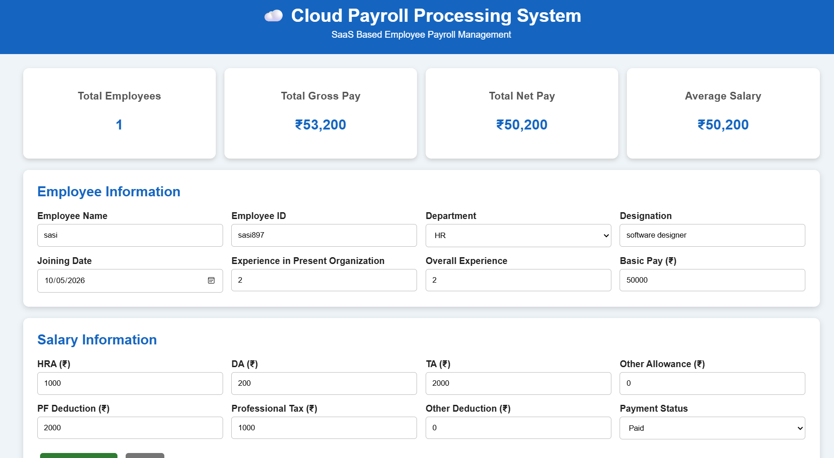
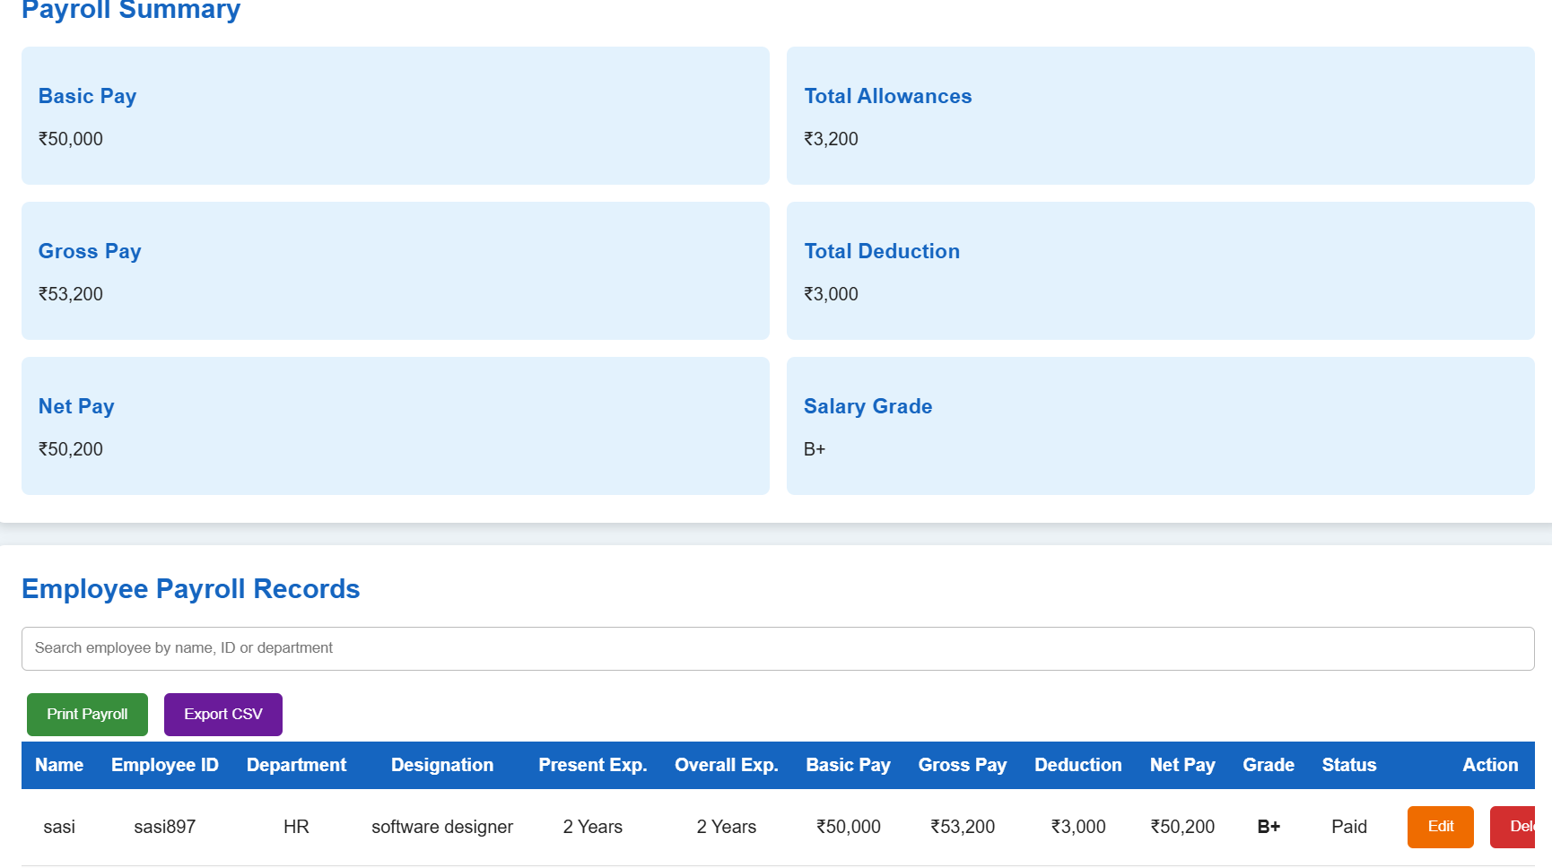
Result: Thus, a Cloud-Based Payroll Processing System was successfully developed using HTML, CSS, and JavaScript. The system calculates Gross Pay, Total Deduction, Net Pay, and Salary Grade automatically and provides additional features such as employee search, editing, deletion, printing, and CSV export, demonstrating the basic concept of SaaS in Cloud Computing.
LAB EXPERIMENT -7
Create a simple cloud software application for Students Attendance System using any Cloud
Service Provider to demonstrate SaaS include the necessary fields such as name of the
students, course, present , Absent, course attendance, OD request, grade, attendance
percentage, etc.
Aim: To develop a simple Cloud-Based Students Attendance System using HTML, CSS, and JavaScript to demonstrate the Software as a Service (SaaS) model, including student details, present/absent status, OD requests, attendance percentage, grade, and performance.
PROCEDURE
- Create an HTML file named attendance.html.
- Design the attendance system interface using HTML and CSS.
- Enter student details such as Name, Register Number, and Course.
- Enter Working Days, Present Days, and Absent Days.
- Enter OD Request and OD Days.
- Calculate attendance percentage automatically.
- Assign Grade and Performance based on attendance percentage.
- Display student attendance records in a table.
- Add features such as Search, Edit, Delete, Print, and CSV Export.
- Run the application in a web browser and deploy it on a cloud service to demonstrate SaaS.
PSEUDO CODE
START
Enter Student Name
Enter Register Number
Enter Course
Enter Working Days
Enter Present Days
Enter Absent Days
Enter OD Request
Enter OD Days
Calculate Attendance Percentage
Attendance % = ((Present Days + OD Days) / Working Days) × 100
IF Attendance >= 90
Grade = A+
ELSE IF Attendance >= 80
Grade = A
ELSE IF Attendance >= 70
Grade = B+
ELSE IF Attendance >= 60
Grade = B
ELSE IF Attendance >= 50
Grade = C
ELSE
Grade = F
Display Attendance Percentage
Display Grade and Performance
Store Student Record
Provide Search, Edit, Delete, Print and CSV Export
END
Output:
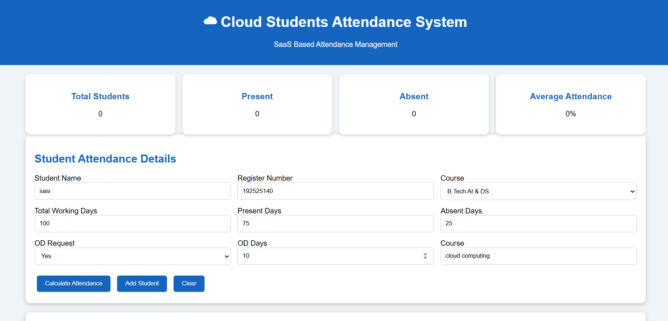
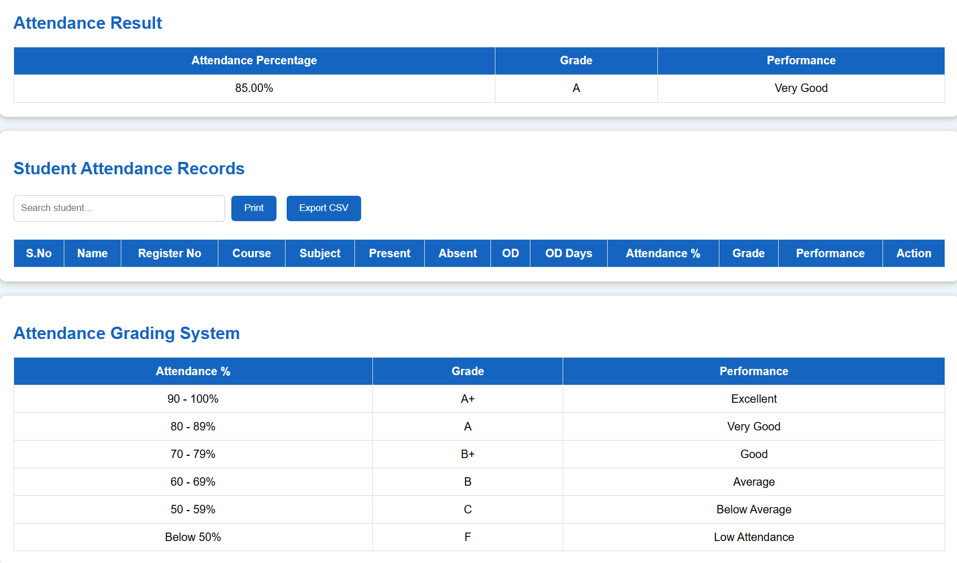
Result:
Thus, the Cloud-Based Students Attendance System was successfully developed using HTML, CSS, and JavaScript. The system calculates attendance percentage and grade automatically and provides features such as OD request, search, edit, delete, print, and CSV export, demonstrating the basic concept of SaaS in Cloud Computing.
LAB EXPERIMENT -8
Create a simple cloud web application for student counselling system using any Cloud
Service Provider to demonstrate SaaS with the fields of student name, age, address, phone,
subjects studied, Year of passing, percentage of marks, domain interest, etc.
Aim: To develop a simple Cloud-Based Student Counselling System using HTML, CSS, and JavaScript to demonstrate the Software as a Service (SaaS) model, with student details such as name, age, address, phone number, subjects studied, year of passing, percentage of marks, domain interest, and career goal. SaaS applications can be accessed through a web browser over the Internet.
PROCEDURE
- Create an HTML file named counselling.html.
- Design the student counselling interface using HTML and CSS.
- Enter student details such as Name, Age, Address, and Phone Number.
- Enter academic details such as Subjects Studied, Year of Passing, and Percentage.
- Select the student's Domain Interest.
- Enter the Career Goal, Counsellor Name, and Counselling Remarks.
- Select the Counselling Status.
- Use JavaScript to store and display student records.
- Add features such as Search, Edit, Delete, Print, and CSV Export.
- Deploy the web application using a cloud service provider to demonstrate SaaS.
PSEUDO CODE
START
Enter Student Name
Enter Age
Enter Address
Enter Phone Number
Enter Subjects Studied
Enter Year of Passing
Enter Percentage of Marks
Select Domain Interest
Enter Career Goal
Select Counselling Status
Enter Counsellor Name
Enter Counselling Remarks
Store Student Details
Display Student Record
IF Percentage >= 90
Recommendation = Advanced Career Opportunities
ELSE IF Percentage >= 75
Recommendation = Good Career Opportunities
ELSE IF Percentage >= 60
Recommendation = Skill Development Recommended
ELSE
Recommendation = Foundation and Career Guidance
Provide Search, Edit and Delete options
Provide Print and CSV Export options
END
Output:
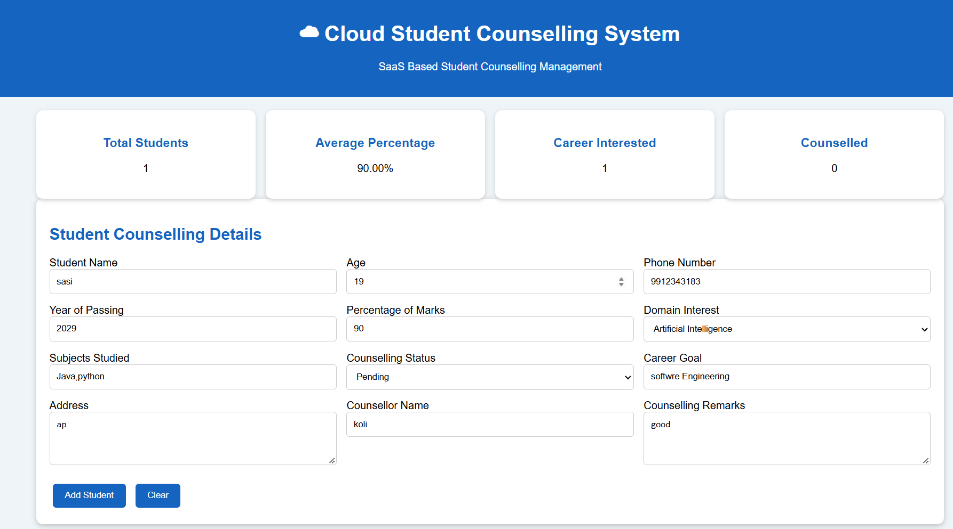

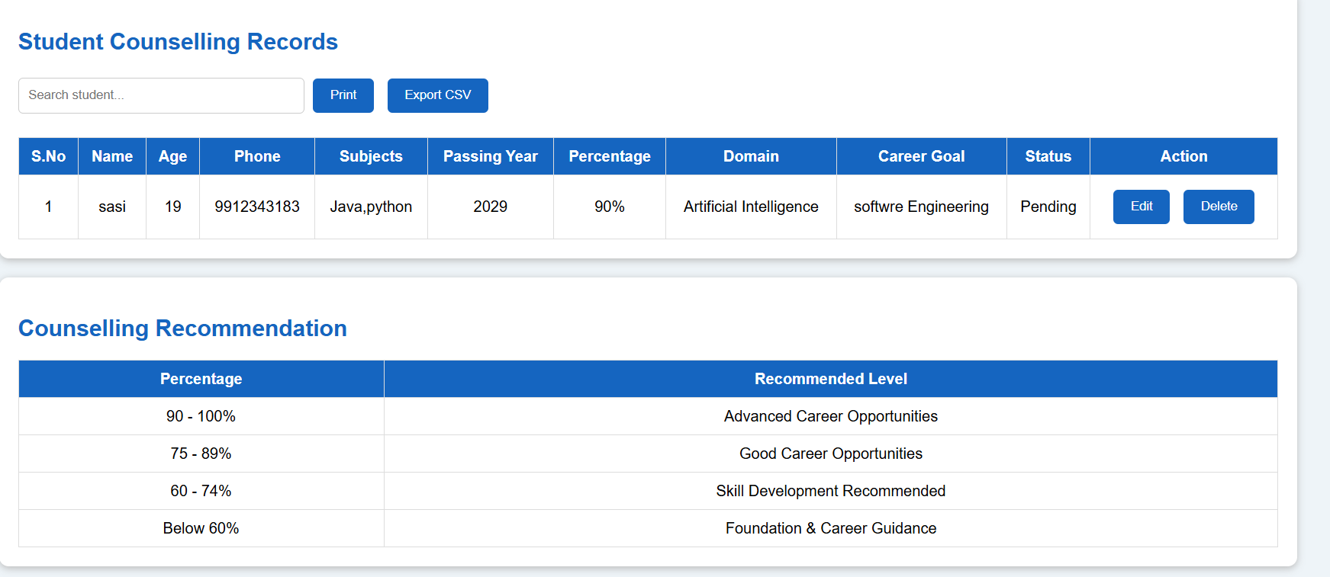
Result: Thus, the Cloud-Based Student Counselling System was successfully developed using HTML, CSS, and JavaScript. The system stores student academic and personal details, provides domain and career guidance information, and supports search, edit, delete, print, and CSV export features, demonstrating the basic concept of SaaS in Cloud Computing.

LAB EXPERIMENT -9
Create a simple cloud software application for Hospital information system for SIMATS Hospital using any Cloud Service Provider to demonstrate SaaS with fields of patient name, age, address, phone, email, Attender name, attender phone, doctor name, diseases, etc.
Aim: To develop a simple Cloud-based Hospital Information System for SIMATS Hospital using a Cloud Service Provider to demonstrate Software as a Service (SaaS). The application stores and manages patient, attender, doctor, and disease details through a web-based interface.
PROCEDURE
- Select a Cloud Service Provider such as Google Firebase, AWS, or Microsoft Azure.
- Create a cloud-based web application for the hospital.
- Design a form to collect patient information.
- Include fields such as:
  - Patient Name
  - Age
  - Address
  - Phone
  - Email
  - Attender Name
  - Attender Phone
  - Doctor Name
  - Disease
- Connect the application to a cloud database.
- Store the entered patient details in the cloud.
- Provide options to add, view, update, and delete patient records.
- Test the application using sample patient data.
- Access the application through a web browser to demonstrate SaaS.
PSEUDOCODE
START
Connect to Cloud Database
Display Hospital Information System
Input Patient Name
Input Age
Input Address
Input Phone
Input Email
Input Attender Name
Input Attender Phone
Input Doctor Name
Input Disease
Validate the entered details
IF details are valid THEN
Store patient details in Cloud Database
Display "Patient Record Saved Successfully"
ELSE
Display "Enter Valid Details"
END IF
Display Patient Records
Allow user to:
Add Record
View Record
Update Record
Delete Record
STOP
Output:
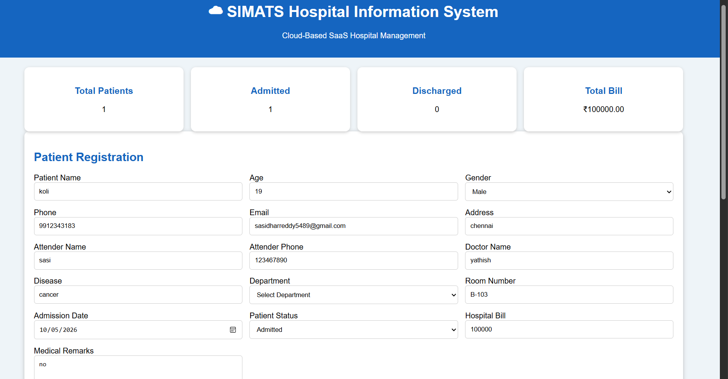
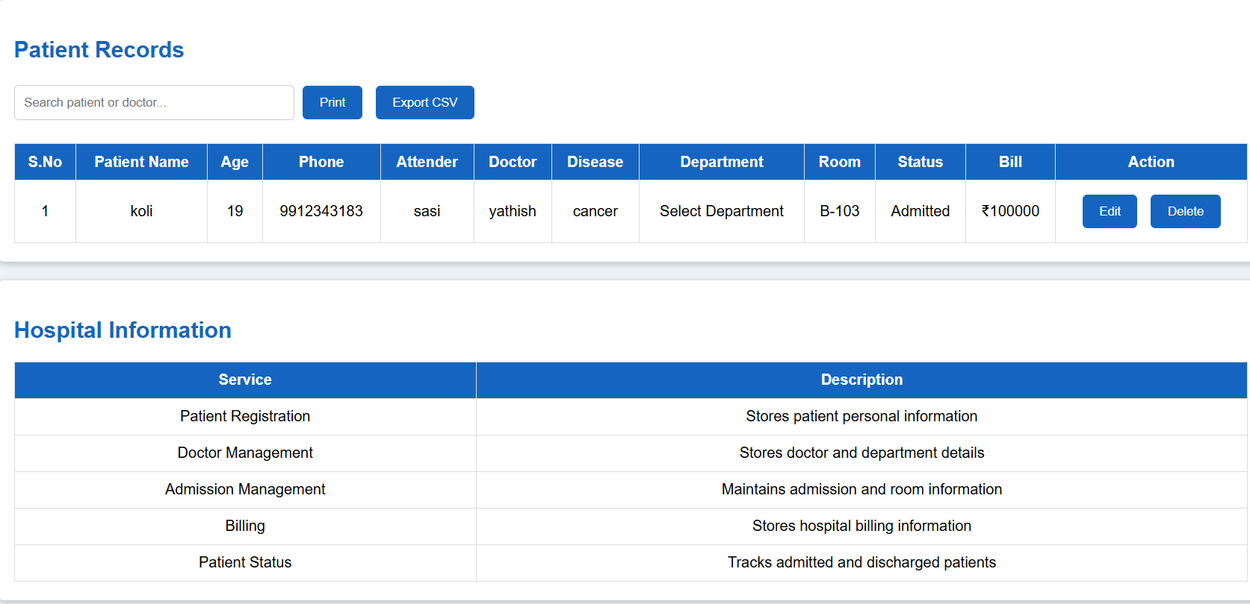
Result: Thus, a simple Cloud-based Hospital Information System for SIMATS Hospital was designed successfully using a Cloud Service Provider. The system stores and manages patient, attender, doctor, and disease details through a web-based SaaS application.

LAB EXPERIMENT -10
Create a simple cloud software application to run a c program to display the student information using any Cloud Service Provider to demonstrate SaaS with the template of student name, reg no, address, phone, age, courses, grades and attendance report, progress report, Semester mark sheet forms
Aim: To develop a simple Cloud-based Student Information System using any Cloud Service Provider to demonstrate Software as a Service (SaaS). The application runs a C program and displays student details such as name, register number, address, phone, age, courses, grades, attendance, progress report, and semester mark sheet.
PROCEDURE
- Select a Cloud Service Provider such as Google Cloud, AWS, or Microsoft Azure.
- Create a cloud-based application to run the C program.
- Create a C program to accept student information.
- Include the following details:
  - Student Name
  - Register Number
  - Address
  - Phone Number
  - Age
  - Courses
  - Grades
  - Attendance Report
  - Progress Report
  - Semester Mark Sheet
- Compile and execute the C program in the cloud environment.
- Enter sample student information.
- Display the entered details in a structured format.
- Store the information in the cloud if database storage is provided.
- Access the application through a web browser to demonstrate SaaS.
PSEUDOCODE
START
Connect to Cloud Service
Input Student Name
Input Register Number
Input Address
Input Phone
Input Age
Input Courses
Input Grades
Input Attendance
Input Progress Report
Input Semester Marks
Display Student Information
Display Name
Display Register Number
Display Address
Display Phone
Display Age
Display Courses
Display Grades
Display Attendance
Display Progress Report
Display Semester Mark Sheet
Store/Save Student Details in Cloud
STOP
Output:
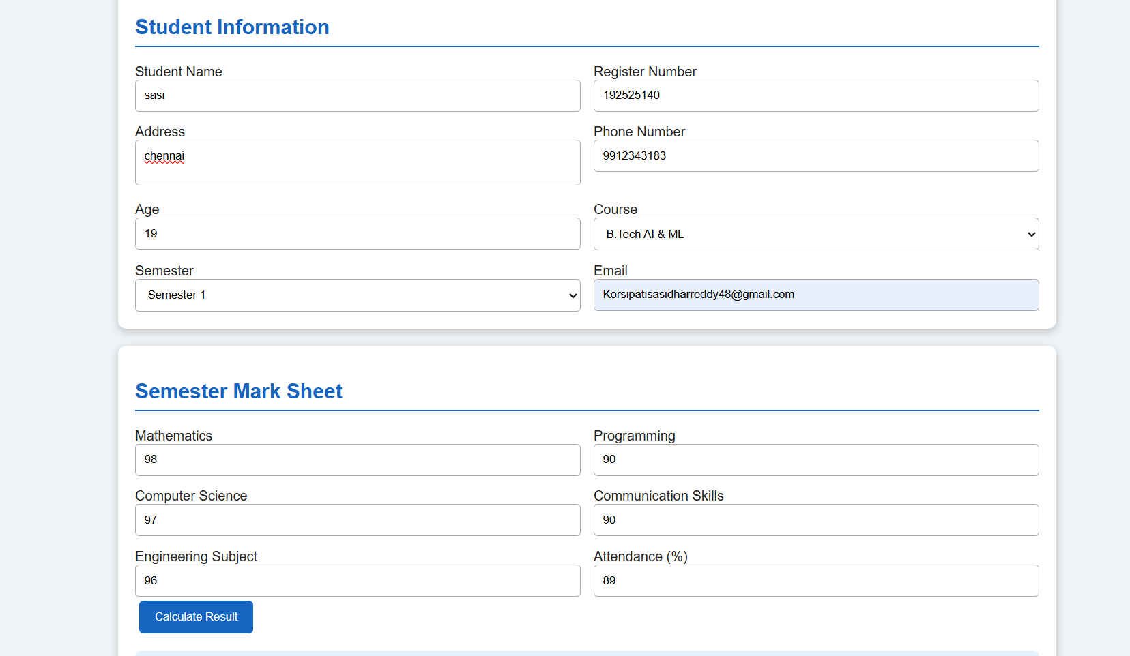
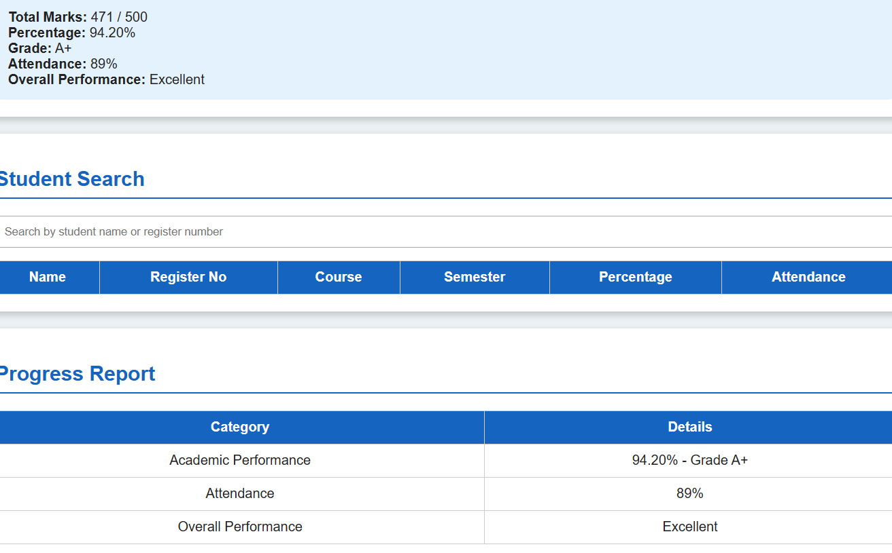
Result: Thus, a simple Cloud-based Student Information System was successfully developed to run a C program and display student information. The system demonstrates SaaS by allowing student details, grades, attendance, progress reports, and semester marks to be accessed through a cloud-based application.

LAB EXPERIMENT -11
Create a simple cloud software application for online super market using any Cloud Service Provider to demonstrate SaaS with the template of customer name, address, phone, email, items, quantity etc. with the item classification form.
Aim: To develop a simple Cloud-based Online Super Market Application using any Cloud Service Provider to demonstrate Software as a Service (SaaS). The application manages customer details, item classification, product selection, quantity, price, and order information through a web-based interface.
PROCEDURE
- Select a Cloud Service Provider such as Google Firebase, AWS, or Microsoft Azure.
- Create a cloud-based web application for the online supermarket.
- Create a customer information form.
- Include the following fields:
  - Customer Name
  - Address
  - Phone Number
  - Email
  - Item Classification
  - Item Name
  - Quantity
  - Price
  - Total Amount
- Create an Item Classification Form with categories such as:
  - Fruits & Vegetables
  - Groceries
  - Dairy Products
  - Beverages
  - Snacks
  - Household Items
- Allow the customer to select items and enter the required quantity.
- Calculate the total price automatically.
- Store customer and order details in the cloud database.
- Display the order summary.
- Test the application through a web browser to demonstrate SaaS.
PSEUDOCODE
START
Connect to Cloud Database
Display Online Super Market
Input Customer Name
Input Address
Input Phone
Input Email
Display Item Classification
Select Item Category
Select Item Name
Input Quantity
Input Price
Calculate Total Amount
Total = Quantity × Price
Display Order Details
IF customer details are valid THEN
Save customer and order details in Cloud Database
Display "Order Placed Successfully"
ELSE
Display "Enter Valid Details"
END IF
Display Order Summary
STOP
Output: 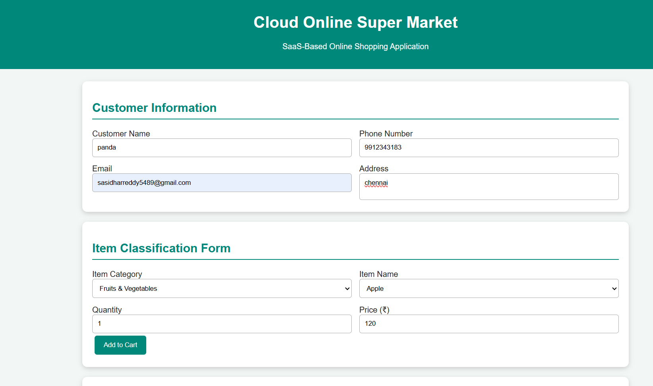
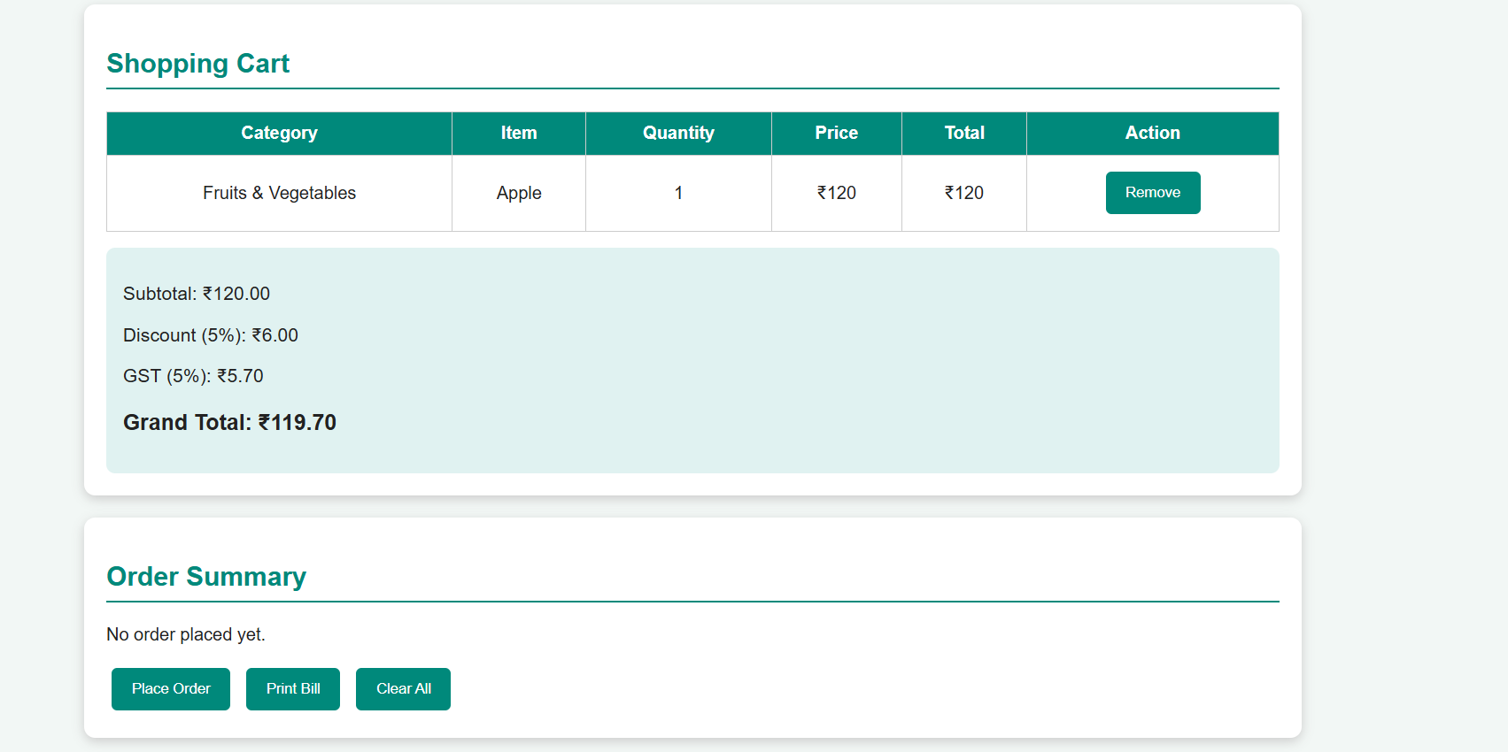
Result: Thus, a simple Cloud-based Online Super Market Application was successfully developed to manage customer information, item classification, product selection, quantity, and order details. The application demonstrates SaaS by providing the supermarket service through a web-based cloud application.

